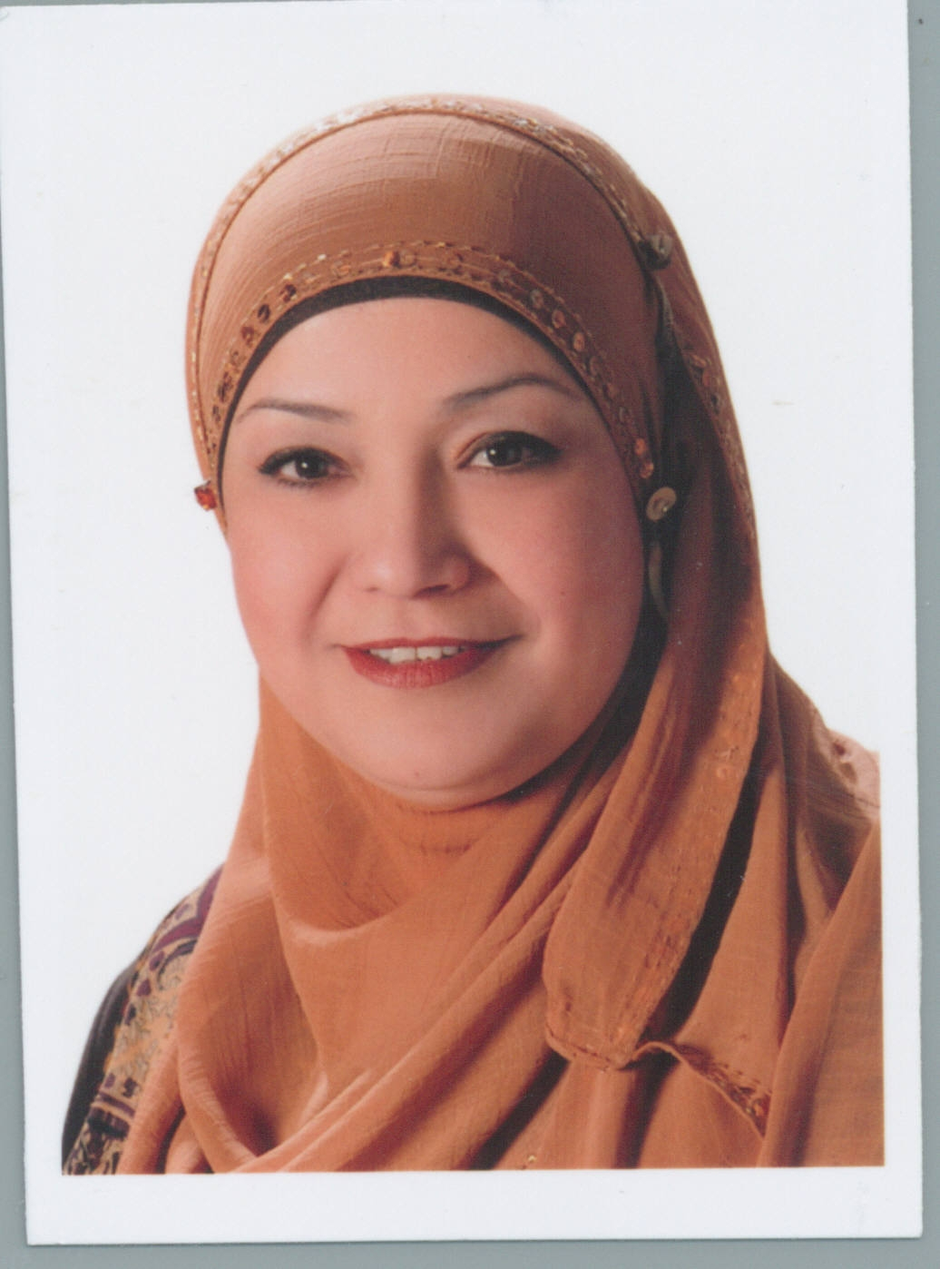
CURRICULUM VITAE INFORMATION FORM
PERSONAL DETAILS
Full Name | Bani Ta’an, E. Shahnaz
Sport City
Amman
Jordan
Telephone | +962 6 5152530 |  |  | Mobile | +962 777498873
Mobile2 | +971 506538087
e-mail | shhnztani@yahoo.com |  |  | Date of birth | 1st.Dec.1967
Nationality | Jordanian |  |  | Marital Status | Married
EDUCATION AND QUALIFICATIONS
Certificate |  | Year of Graduation | Name of School, College, University
B.A. in Arabic Literature & Language  High School/ Scientific Branch |  | 1990  1985 | University of Yarmouk  Irbid High School

EMPLOYMENT HISTORY
Name of employer and address or location | Dates employed | Position held (job title)
University of Jordan  Amman 11942  Jordan | 22nd.Aug.1992  To  Currently | - President of UJ Library Court/ Diwan  - Court Administrative Officer in Faculty of Art.  - Coordinator of Classroom Teachers Panel in UJ Model School.  - Coordinator of Public Relations in UJ Model School.  - Member in Discipline Council in UJ Model School.  - Member in Parents and Teaching Stuff Council in UJ Model School.  - Classroom Teacher for 15 years in UJ Model School.  - President of King Abdullah II School For IT Court/ Diwan from 10/8/2010 until now

OTHER SKILLS AND TRAINING COURSES
UJ Center of Consultations
- 9th - 24th.Dec.2007: Court Management & Files Archiving.
- 1st - 26th.Dec.2007: English Conversation (Level Med.).
UJ Model School
- 24th.Feb – 2nd.April.2001: Procedural Research Course.
- 24th.Feb – 24th.March.2001: Computer Use in Education Course.
- 11th – 18th.Jan.2001: Measurement & Evaluation Course.
- 15th – 26th.Oct.2000: Teaching & Learning Course.
- 1st. – 15th.May.2000: Use of Cognitive Computer Tools Course.
- 4th.March – 20th.May.1999: Modern Strategies in Teaching Scientific Concepts Course.
- 24th.March – 3rd.May.1998: Teaching Science for Basic Phase between Traditional & Constructive.
University of Yarmouk (Department of Continuing Education)
- 15th. – 25th.Feb.1992: Hand typing Course
HOBBIES, INTERESTS OR ACTIVITIES
Swimming
Travel
Reading
REFERENCES
Name | High Excellency. Adbullah Elayan | Name | Dr. Refa’h Al-Zo’ubi
Address | Institute of Training | Address | Faculty of Educational Science  UJ
Telephone | +962 79591723 | Telephone | +962 6 5355099
Certificates & Documents are available upon request.

